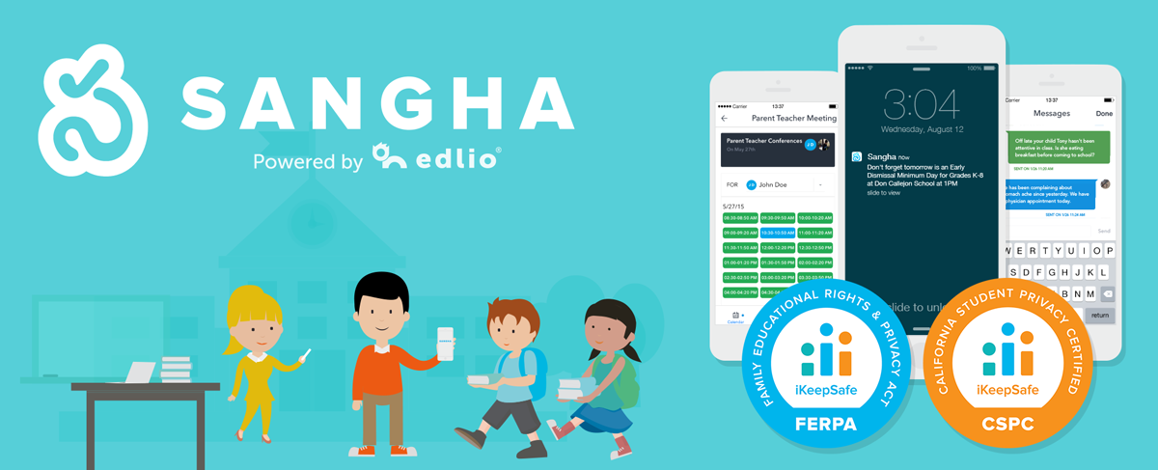

Sangha Parent Engagement App
Connect and engage with parents and families in a more personalized and effective way with Edlio's parent engagement app, Sangha. Your whole staff will use Sangha for sending announcements, alerting everyone in urgent situations, planning sign-up events, scheduling parent-teacher meetings and messaging parents. Admins love that everything is fully transparent, with all teachers using the same platform for easy auditing, and has earned FERPA and California Student Data Privacy Certifications. Teachers love getting permission slips and class messages out reliably to families, with responses taking minutes rather than days. And parents love that they're not getting large amounts of communication from multiple channels that doesn't relate to their kids.

How does it work?
Administrators, teachers and organizers can create and manage events with automatic RSVP tracking, integrated forms and e-signatures, volunteering and material donation requests, and payments, fundraising and selling items/tickets.
- Administrators, teachers and organizers create and manage events and messages using a single school web app.
- Parents receive only the information relevant to their children in a format they can act upon, right from their phone or e-mail.
- Administrators, teachers and organizers track and manage parent responses from within the school app.

Schoology Parent Sign-up/steps

- Teacher invites parents via email provided.
- Parents will receive an invitation.
- Parents click on the create account link which will take them to Schoology via the Internet
- Parents will be asked to put in the access code that was sent with their invitation
- Parents will have to register their name and contact information
- After submitting information parents will be taking to the teachers Schoology course.

